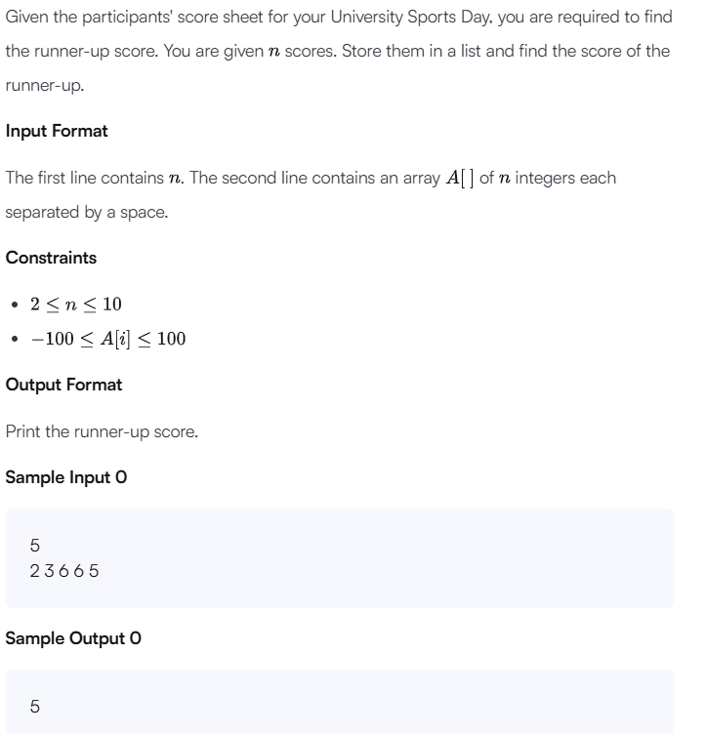
n = int(input())
arr = map(int, input().split())
arr = list(set(arr))
arr.sort()
print(arr[-2])

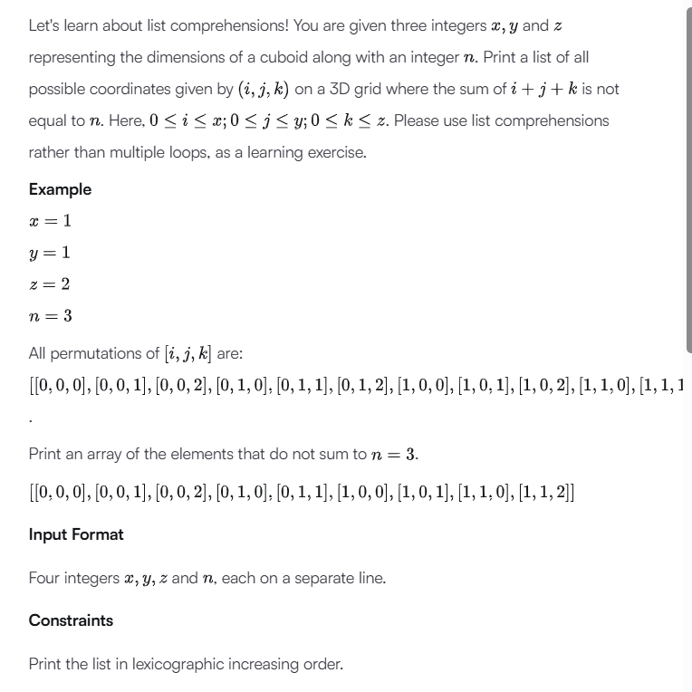
x = int(input())
y = int(input())
z = int(input())
n = int(input())

print([[i, j, k]
for i in range(x + 1)
for j in range(y + 1)
for k in range(z + 1)
if i + j + k != n])
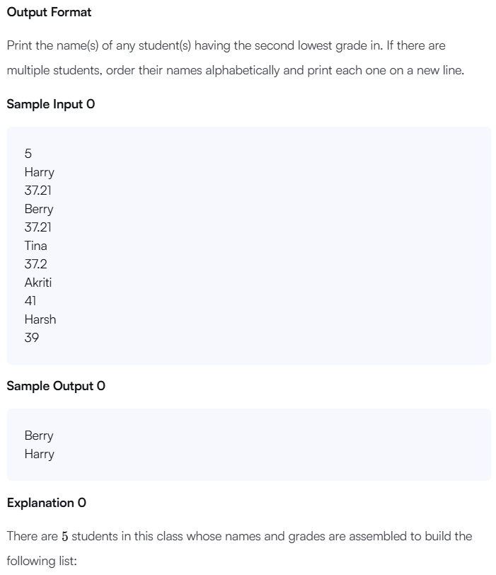
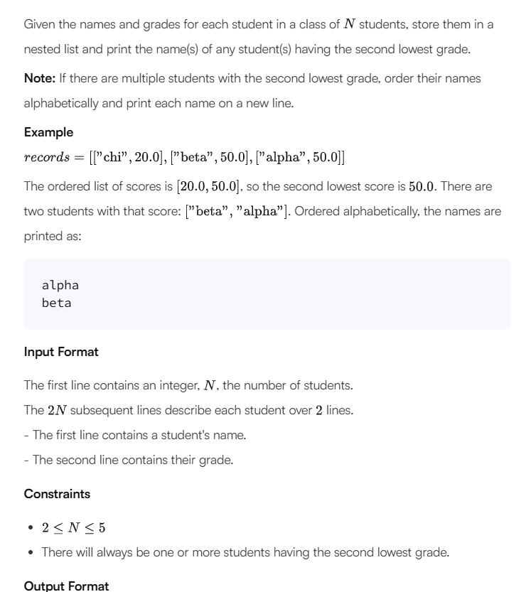
if __name__ == '__main__':
students = []

# Step 1: Take input
for _ in range(int(input())):
name = input()
grade = float(input())
students.append([name, grade])

# Step 2: Get unique sorted grades
grades = sorted(set([g for n, g in students]))

# Step 3: Find second lowest grade
second_lowest = grades[1]

# Step 4: Get names with second lowest grade
names = []
for n, g in students:
if g == second_lowest:
names.append(n)

# Step 5: Sort names
names.sort()

# Step 6: Print result
for name in names:
print(name)

